Patient Health History

Today’s Date Signature of Patient

/ /

Patient Title: (check one) Mr. Mrs. Ms. Miss Dr. Prof. Rev.
First Name Nick Name
Last Name Middle Name Suffix
Address 1
Address 2
City State Zip Code
Primary Phone Secondary Phone
Mobile Phone
Home email Work Email
By providing my email address, I authorize my doctor to contact me via the email address(es) provided.
Which email address would you like us to use to communicate with you? (check one) Home Work
Contact Method (check one)
Primary Phone Secondary Phone Mobile Phone Home Email Work Email
Date of Birth Age Gender (check one) Male Female Unspecified

/ /
Marital Status (check one) Single Married Other SSN
Employment Status (check one)
Employed FT Student PT Student Other Retired Self Employed
Race (check one)
White Black/African American Hispanic American Indian/Alaskan Native
Asian Asian Indian Chinese Filipino Japanese Korean Vietnamese Native Hawaiian or other Pacific Island
Samoan Guamanian or Chamorro Other I choose not to specify
Multi-Racial (check one) Yes No Unknown
Ethnicity (check one) Hispanic or Latino Not Hispanic or Latino I choose not to specify
Preferred Language (check one)
English Spanish American Sign Language Chinese French German
Tagalog Vietnamese Italian Korean Russian Polish
Arabic Portuguese Japanese French Creole Greek Hindi
Persian Urdu Gujarati Armenian I choose not to specify

Continued …

Verification Question (choose only one question by circling the question, then give the answer to that question)
What is the name of your favorite pet? In what city were you born? What high school did you attend?
What is your favorite movie? What is your mother’s maiden name? On what street did you grow up? What was the make of your first car? When is your anniversary?
Verification Answer to the Chosen question:
Answers must be at least 6 characters.
Do you currently smoke tobacco of any kind? Yes Former smoker Never been a smoker
If yes, how often do you smoke: Current every day smoker Current sometimes smoker
If yes, what is your level of interest in quitting smoking?
❑ 0  1  2  3  4  5  6  7  8  9  10
No interest Very Interested
Current medications, including frequency and dosage if known. If there are no current medications,
check here:
Dosage
Dosage
1) 5)
2) 6)
3) 7)
4) 8)
List any known allergies you have had to any medications.
If no allergies are known, check here:
1) 3)
2) 4)
Briefly list your main health problems:

Has any doctor diagnosed you with Hypertension presently? Yes No If yes, describe:

Has any doctor diagnosed you with Diabetes presently? Yes No If yes, what kind? Type I Type II
If yes to Diabetes, was your blood lab-work test for hemoglobin A1c > 9.0%? Yes No Not Sure
If yes, other comments regarding Diabetes:
Have you had an X-ray or CT scan or MRI of your low back spine in the past 28 days? Yes No

To be performed by clinic staff:

Height: inches Weight: pounds BP: /

Occupation: __________________________________ Work Phone: __________________________
Primary Care Physician: _________________________________
Emergency Contact: _______________________ Relation: _____________Phone:________________

How did you hear about our office? ______________________________________________________

Primary Insurance:_______________________Secondary Insurance:________________________

Is this a result of an Auto or Work Injury: Y N If Yes…
Name & address of Workman’s Comp Carrier or Auto Insurance ___________________________________________________________________________________
___________________________________________________________________________________
Date of Injury___________________________ Claim #_____________________________________
Contact Person______________________________________ Phone___________________________
Attorney Name, address & phone:
______________________________________________________________________________________________________________________________________________________________________

The information contained in this packet is true and accurate to the best of my knowledge. I understand and agree that health and accident insurance policies are an arrangement between an insurance carrier and me. I authorize the release of any medical or other information necessary to process this claim. Please allow Absolute Wellness Ltd. to also attain information on my medical history in order to better understand my condition. I also request payment of government benefits either to myself or to the third party who accepts assignment. Furthermore, I understand that Absolute Wellness Ltd. will prepare any necessary reports and forms to assist me in making collections from the insurance carrier and that any amount authorized to be paid directly to Absolute Wellness Ltd. will be credited to my account upon receipt. I clearly understand and agree that I am personally responsible for payment. I further authorize Absolute Wellness Ltd. to call me at the above listed number for appointment reminders and other office matters. I understand that Absolute Wellness Ltd. is the corporate name and is operating as Lakeside Chiropractic.

________________________________________________________________________ ______________________________
Patient/Guardian Signature Date

Consent to evaluate and adjust a minor child
I, ______________________________being the parent or legal guardian of _____________________
Have read and fully understand the above terms of acceptance and hereby grant permission for my child to receive chiropractic care.
______________________________
Signature

When a patient seeks chiropractic care it is essential for both the patient and doctor to be working towards the same objective. It is important that the patient understand both the objective and method that will be used to attain this goal. This will prevent any confusion or disappointment.

CHIROPRACTIC MEDICINE
Chiropractic medicine is made up of many tools and techniques. The most important tool and technique is the manual manipulation or the “adjustment”. An adjustment is a specific application of forces to facilitate the body’s correction of a mal-alignment of the joints in the body. Techniques used to aid the adjustment include but are not limited to: soft tissue techniques, stretching, rehabilitation exercises, nutritional advice and life-style advice. I understand that the practice of neither chiropractic nor medicine is an exact science and that my care may involve the making of judgments based upon the facts known to the doctor at the time; that it is not reasonable to expect the doctor to be able to anticipate or explain all risks and complications; that an undesirable result does not necessarily indicate an error in judgment; no guarantee as to results has been made to nor relied upon by me, and I wish to rely on the doctor to exercise judgment during the course of the procedure which he/she feels at the time, based upon the facts known, is in my best interests. I have also been advised that although the incidence of complications associated with chiropractic services is very low, anyone undergoing chiropractic procedures should know of possible complications which have been alleged. These include, but are not limited to, fractures, disk injuries, strokes, dislocations, sprains, and those which relate to physical aberrations unknown or reasonably undetectable by the doctor.

HEALTH
Health is the state of optimal physical, mental, and social well being, not merely the absence of disease or infirmity. Just because there are no symptoms does not mean that there is no problem. If the problem is caught early enough, it can be corrected with minimal pain or discomfort. If the problem is allowed to persist, irreversible changes may occur causing permanent damage and pain. Prevention is the key.

I have read and fully understand the above statements. All questions regarding the doctor’s objectives pertaining to my care in this office have been answered to my complete satisfaction. I request and consent to the performance of chiropractic adjustments, acupuncture and/or other chiropractic procedures on me or the minor in question by any licensed doctor of chiropractic who may be employed by or engaged in practice in Lakeside Chiropractic.

___________________________________________ ___________________
Signature Date

Privacy Practices Acknowledgement:
I have received the Notice of Privacy Practices and have been given an opportunity to review it.

_____________________________________ ____________
Signature Date

PAIN LOCATION

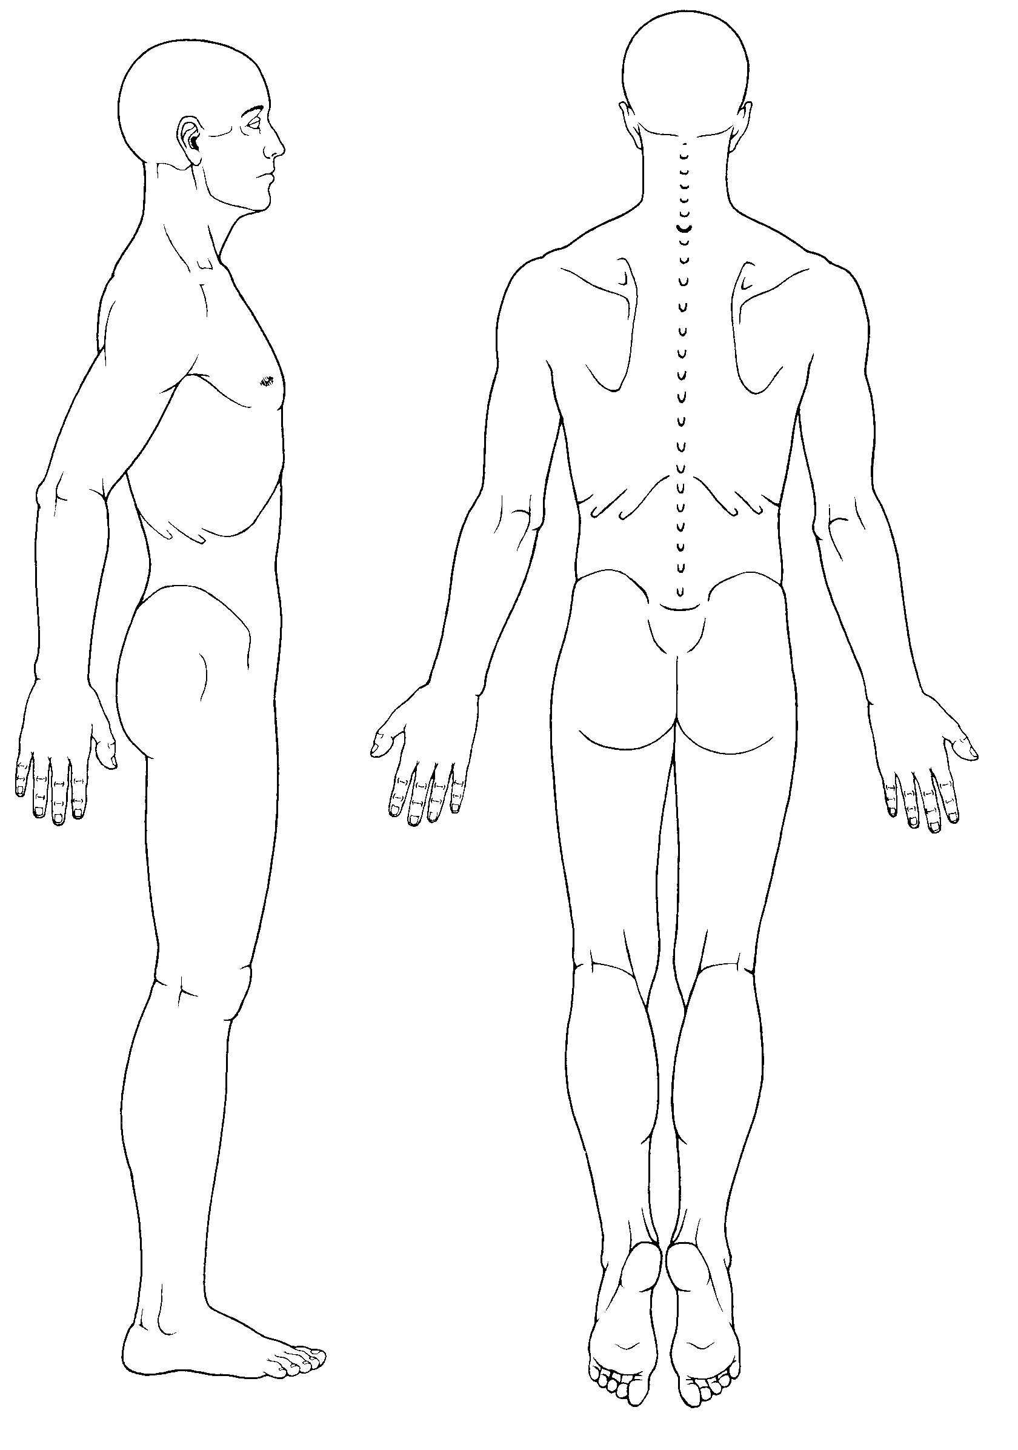
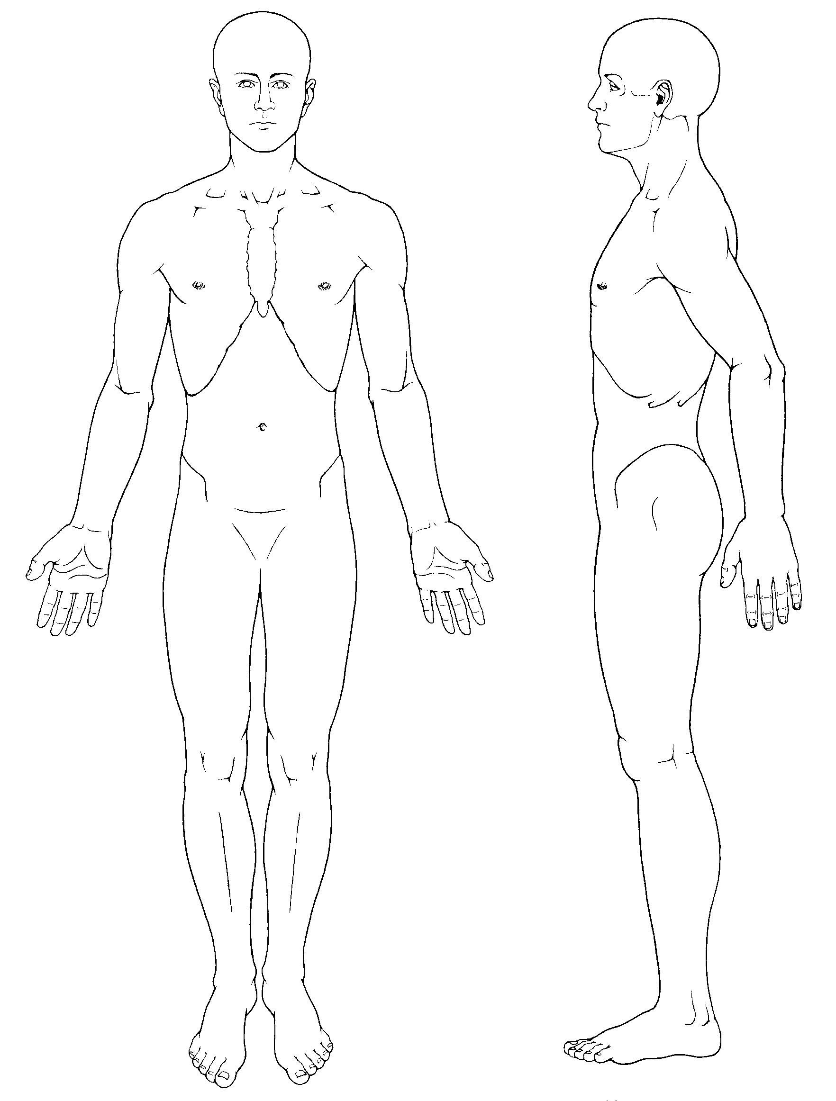

Please number the areas of your complaint on the diagram above and fill in the following chart:

Number | Pain Type | How long have you had it? | What caused it? | 1-10 pain scale &  Frequency
 | Sharp Dull Throbbing  Numbness Aching  Shooting Burning  Tingling Cramps  Stiffness Deep  Other ________________ |  |  | Constant  OR  Come and go
 | Sharp Dull Throbbing  Numbness Aching  Shooting Burning  Tingling Cramps  Stiffness Deep  Other ________________ |  |  | Constant  OR  Come and go
 | Sharp Dull Throbbing  Numbness Aching  Shooting Burning  Tingling Cramps  Stiffness Deep  Other ________________ |  |  | Constant  OR  Come and go
 | Sharp Dull Throbbing  Numbness Aching  Shooting Burning  Tingling Cramps  Stiffness Deep  Other ________________ |  |  | Constant  OR  Come and go

Health History
Circle P if you’ve had this condition in the past (6 months).
Circle C if it is a current problem (1 month).
Leave Blank if Never.
Hospitalizations
110. List Dates and Reasons: ________________________________________________________________________________________________________________________________________
Childhood Diseases
- P C Measles
- P C Chicken Pox
- P C Mumps

Women Only
- P C Live Births
- P C Miscarriage
- P C Painful Periods
- P C Excessive Flow
- P C Irregular Cycles
- P C Vaginal Burning/Itching
- P C Hot Flashes
- Date Last Period Began: ___/___/___
- Date of Last PAP Test: ___/___/___
- Date of Last Mammogram: ___/___/___
Accidents/Trauma
- P C Motor Vehicle Accidents
- P C Other Trauma/Accidents
Men Only
- P C Testicular Swelling/Pain
- P C Prostate Problems
Gastrointestinal
- P C Poor Appetite
- P C Poor Digestion
- P C Difficulty Swallowing
- P C Belching or Gas
- P C Frequent Nausea
- P C Vomiting
- P C Vomiting Blood
- P C Pain over Abdomen
- P C Ulcer
- P C Black or Bloody Stools
- P C Liver Problems
- P C Gall Bladder Problems
- P C Jaundice
- P C Hernia
- P C Diarrhea
- P C Constipation
- P C Hemorrhoids
- P C Appendicitis
Neurologic
- P C Weakness
- P C Twitching
- P C Tremors
- P C Headache
- P C Fainting
- P C Dizziness
- P C Convulsions
- P C Epilepsy
- P C Numbness/Tingling
- P C Arm/Leg Pain
- P C Mental Disorder
Skin
- P C Itching
- P C Bruising Easily
- P C Change in Mole(s)
- P C Skin Cancer
Eye, Ear, Nose, Throat
- P C Poor Vision
- P C Pain in Eye(s)
- P C Difficulty Hearing
- P C Nosebleeds
- P C Nose Problems
- P C Sinus Trouble
- P C Dental Problems
- P C Hoarseness
- P C Tonsilectomy
Genitourinary
- P C Frequent Urination
- P C Painful Urination
- P C Blood in Urine
- P C Kidney Disease
- P C Urinary Infection
- P C Inability to Control Urination
- P C Difficulty Starting Urine Flow
- P C Get up __times per night to urinate
- P C Breast Lump or Pain
- P C Venereal Infection
- P C Sexual Difficulties
Cardiovascular
- P C Irregular Heartbeat
- P C High Blood Pressure
- P C Pain Over Heart
- P C Previous Heart Trouble
- P C Ankle Swelling
- P C Varicose Veins
- P C Rheumatic Fever
- P C Stroke
General
- P C Fever
- P C Chills
- P C Night Sweats
- P C Loss of Sleep
- P C Fatigue
- P C Nervousness
- P C Weight Loss or Gain
- P C Allergies
- P C Bleeding Problems
- P C Anemia
- P C Diabetes
- P C Cancer
- P C Thyroid Disease/Goiter
- P C Alcoholism
- P C Drug Abuse
- P C HIV Risk Factors
Respiratory
- P C Difficult Breathing
- P C Chronic Cough
- P C Spitting Phlegm
- P C Spitting Blood
- P C Wheezing/Asthma
- P C Pneumonia
- P C Tuberculosis
Family History (Circle) Mom/ Dad
- Diabetes M D
- Kidney Disease M D
- High Blood Pressure M D
- Heart Disease M D
- Cancer,
Type: ____________ M D

Exercise (Circle)
- None
- 1-2 times a week
- 3-5 times a week
- 6-7 times a week
Habits
- P C Smoking ____packs/day
- P C Drinking
- P C Recreational Drug Use
Nutritional Status
- P C Tell me about Your Nutrition ____________________________
- P C Nutritional Supplements ____________________________
- P C Herbs/Botanicals ____________________________
Medications
- P C Prescription
- P C Non-prescription
Surgeries
111. List Dates and Reasons: ________________________________________________________________________________________________________________________________________
Musculoskeletal
- P C Neck Stiffness/Pain
- P C Pain Between Shoulders
- P C Low Back Pain
- P C Swollen Joints
- P C Painful Joints
- P C Muscle Aches/Soreness
- P C Spinal Curvature (Scoliosis)
- P C Arthritis

Lakeside Chiropractic
Health Starts Here!
7229 State Park Rd Phone: (847) 587-0003
Fox Lake, IL 60020 Fax: (847) 587-0210
Foxlakechiropractic.com
Office Policies

Welcome to our office! Our goal is to serve you with exceptionally friendly and prompt service, and provide the best family health care available. It is our experience that our patients who follow these simple guidelines obtain the best results and greatest benefits to their health.

Office Hours
Monday* & Thursday* 9:00 a.m. – 6:15 p.m.
Tuesday Closed
Wednesday 9:00 a.m. – 5:00 p.m.
Friday 9:00 a.m. – 6:00 p.m.
Saturday 9:00 a.m. – 12:00 p.m. (Must have appointment)

Dr.’s Tews are occasionally out of the office to attend seminars and conferences to further their education. We will build your schedule around those times.

Appointment Scheduling & Missed Appointments

Dr.’s Tews have designed a specific course of action to allow proper care, a must for spinal postural correction. If an appointment must be changed, 24 hour notice is appreciated. All missed appointments should be made up later the same day or within 24 hours. Please let us know and changes will be made accordingly.

Financial Agreements

It is your payment that allows us to continue providing high levels of professional care, maintain our facility, and pay our staff. If for any reason you cannot keep your financial agreement, please inform us immediately to eliminate any misunderstandings. If you have the desire to receive care in our office, we will make every attempt to make affordable arrangements.

Remember

Spinal correction and healing take time. If you do not feel satisfied with your body's responses, please make an appointment to discuss this with Dr’s Tews. We want you to get the most from your chiropractic care. Also, feel free to ASK QUESTIONS. In the end you are the one responsible for your health and we want you to feel as comfortable and competent as possible.

Referrals

The health of your loved ones can greatly depend on your referrals. If you know someone who could benefit from our expertise, please let them know about us so we can help them feel better.

